Campaign Overview
Aim (s): | To promote respectful behaviour towards lifeguards and swim teachers and ensure aquatic facilities are safe, inclusive, and enjoyable for all. Aligns with RLSSA’s Strategic Framework (focusing on safety, collaboration, and community empowerment) and supports the Australian Water Safety Strategy (AWSS) 2030’s goals of reducing drowning rates and improving safety in aquatic facilities, while supporting the aquatic workforce, particularly around wellbeing concerns.
Strategic Alignment | RLSSA Strategic Framework:  - Strategic Pillars: Strengthening safety and empowering communities through respect and cooperation  NAIC Strategy 2030:  - Aligns with priorities for workforce safety, diversity, and inclusion  Australian Water Safety Strategy (AWSS) 2030:  - Focuses on reducing drowning in aquatic facilities and ensuring safe environments for recreation
Target audience: | Primary: Families, recreational swimmers, parents, and caregivers.  Secondary: Aquatic facility staff, facility managers, local governments, and industry stakeholders.
Key Objectives: | Key Objectives  - Educate the public on the importance of respecting aquatic staff.  - Encourage positive behaviour changes that reduce occupational violence and aggression.  - Raise awareness of the critical role lifeguards and swim teachers play in ensuring safety at aquatic facilities.
Content Pillars | - Education: Explaining lifeguards' and swim teachers' roles in maintaining safety.  - Awareness: Highlighting the prevalence of aggression towards staff and its consequences.  - Empowerment: Encouraging community collaboration to foster safe and respectful aquatic environments.
Channels | - Socials:  - Facebook  - LinkedIn  - Instagram  - Website news item  - ALM article  - Mainstream media campaign (TV, radio & print)

NEWS STORY
Date & Time | Channels | Copy | Content
Mon 16 Dec | National mainstream media  Industry publications (ALM, Splash, NAIC Partner Newsletters) | ‘Keep Your Cool at the Pool’ Campaign Promotes Respect for Lifeguards  Date: 16 December 2024  Last year, there were more than 2,000 incidents of abuse, violence, and aggression directed at staff working in aquatic facilities around the country. To support the safety and wellbeing of staff working in aquatic facilities, Royal Life Saving Australia has launched the ‘Keep Your Cool at the Pool’ campaign, which sets clear behavioural expectations for patrons and calls for users of aquatic facilities to treat each other and staff respectfully.  “Violence and aggression towards lifeguards and swim teachers are totally unacceptable, and this campaign encourages a collaborative approach to safety by reinforcing a culture of respect, cooperation, and zero-tolerance for aggression in aquatic facilities,” said Royal Life Saving General Manager – Capability and Industry RJ Houston.  “Lifeguards and swim teachers provide a critical lifesaving role to the community and are there to keep everyone safe. When they give instructions to swimmers, this is to maintain a safe and enjoyable environment for all.  “We want aquatic facilities to be safe spaces not only for swimming but for staff to work. That’s why we’re encouraging everyone to ‘Keep Their Cool at the Pool’ this summer and support our lifeguards and swim teachers against occupational violence and aggression.”  The ‘Keep You Cool by the Pool’ campaign has garnered strong support from aquatic industry leaders. Belgravia Group Manager - Health & Safety Scott Vanderheyden emphasised the importance of respect for lifeguards and swim teachers in the community.  “Unfortunately, lifeguards and swim teachers are often abused for providing basic safety instructions to users, such as to keep watch over their children or use a particular area of the facility.  “This can lead to hesitation in providing safety instructions promptly, which is the last thing we want from our lifeguards and swim teachers, as their guidance is essential for everyone’s safety. It’s crucial for all pool users to show respect to lifeguards and swim teachers during their visit,” said Vanderheyden.  AUSTSWIM General Manager Georgie Nichol echoed this sentiment, saying abuse of any kind has no place in public swimming pools: “We stand united with our colleagues at Royal Life Saving in championing a culture of respect and zero tolerance to abuse.  “Swim teachers play an invaluable role in delivering vital water safety education within our communities, and we believe that all educators deserve a workplace where they feel respected, supported, and free from intimidation.  “We are committed to creating a safe and respectful environment for all swim teachers. Let’s stand together to end all forms of abuse and ensure every swim teacher feels respected and valued,” said Nichol.  For more information about the ‘Keep Your Cool by the Pool’ campaign, visit the Royal Life Saving campaign website.  ~ENDS~  Media Contact:  Ross Woodward, Media Key  P: (03) 9769 6488  E: mediakeypr@iprimus.com.au  About Royal Life Saving Australia:  Royal Life Saving Australia is dedicated to the prevention of drowning and the promotion of safe aquatic places and practices through education, research, risk management and advocacy. We are committed to ensuring that all Australians can enjoy water safely and confidently. | 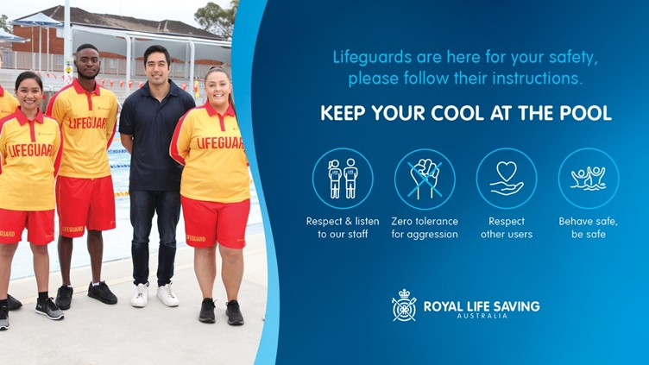  Social tiles can be found here:  https://www.royallifesaving.com.au/Aquatic-Risk-and-Guidelines/safety-programs/keep-your-cool-at-the-pool

SOCIAL MEDIA COPY
Mon 16 Dec | Carousel:  Facebook  LinkedIn | 🏊‍♀️ Let’s create safer aquatic spaces this summer! 🏊‍♂️  Did you know there were more than 2,000 incidents of violence and aggression against staff in aquatic facilities last year?  Lifeguards and swim teachers are here to keep you safe, so let’s show them the respect they deserve. 💙  👉 Follow these steps for a safer and more enjoyable pool visit:  ✅ Listen to lifeguards’ and swim teachers’ instructions.  ✅ Supervise your children at all times.  ✅ Treat staff and fellow swimmers with respect.  Let’s work together to make our pools safe spaces for all. 🌊  📢 Spread the word: Safety starts with you. #KeepYourCool #RespectLifeguards  Call to Action: Visit our website to learn more about the campaign and how you can help create change: https://www.royallifesaving.com.au/about/news-and-updates/news/2024/dec/new-pool-safety-campaign-keep-your-cool-at-the-pool | Carousel
Mon 16 Dec | Structure  A 15-30 second reel combining flat visuals with text overlays and upbeat background music. | Campaign Intro  “Join the movement. #KeepYourCool #RespectLifeguards” | Artwork to be developed:  “Did you know there were more than 2,000 instances of abuse and aggression towards lifeguards and swim teachers last year?”
 | Story / reel  Instragram | Staff Focus  “Join the movement. #KeepYourCool #RespectLifeguards”  Sticker/CTA: Use a poll sticker: "Should aggression towards staff be zero-tolerance?" (Options: Yes/Absolutely) | 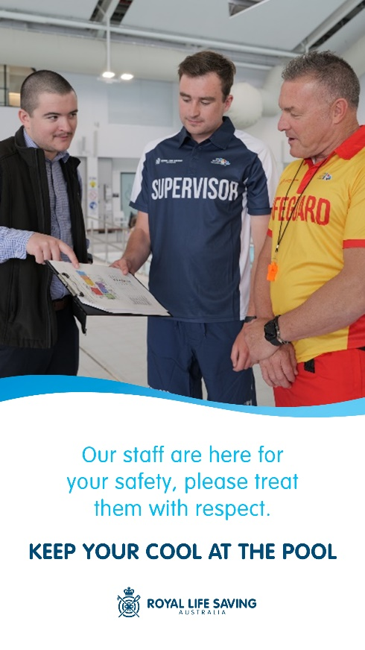
 | Story / reel  Instragram | Lifeguard Focus  Sticker/CTA: Use a question sticker: “What’s one thing you can do to support lifeguards?” | 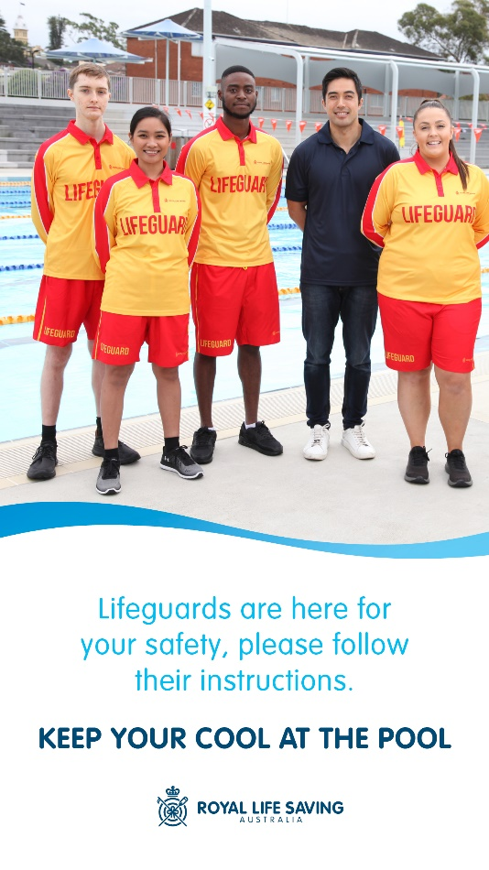
 |  | Swim Teacher Focus  Sticker/CTA: Use an emoji slider with a heart emoji: "How much do you value swim teachers?" ❤️ | 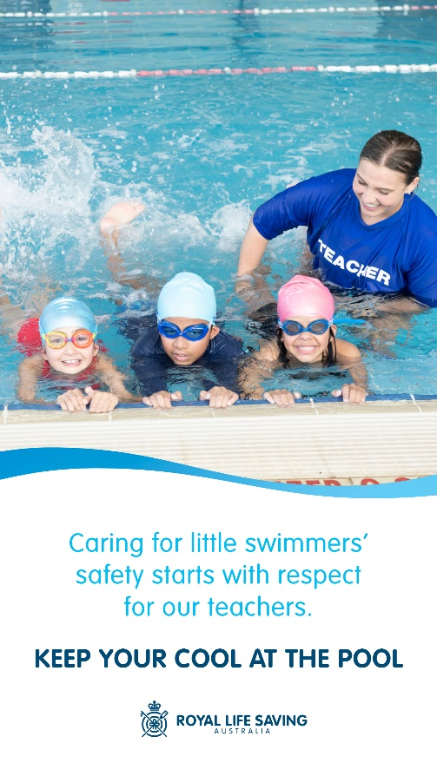
 |  | Campaign Overview:  Captions:  "Join us in making pools safer for everyone."  "Respect starts with you. 💪"  Sticker/CTA: Add a link sticker: "Learn more at https://www.royallifesaving.com.au/Aquatic-Risk-and-Guidelines/safety-programs/keep-your-cool-at-the-pool | 