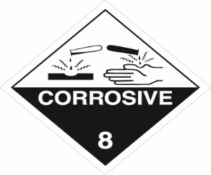
SODIUM
HYPOCHLORITE
UN No: 1791
HAZCHEM CODE: 2X
CLASS PRIMARY: 8
SUPPLIER NAME:
SUPPLIER TEL NO:
MAXIMUM QUANTITY STORED:
This PPE MUST be worn
IN THE EVENT OF AN EMERGENCY CONTACT
NAME: NUMBER:
BCDMH
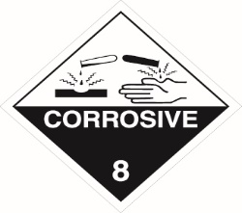
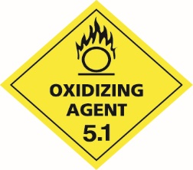
BROMINE
UN No: 3085
HAZCHEM CODE: 2X
CLASS PRIMARY: 5.1
SUPPLIER NAME:
SUPPLIER TEL NO:
MAXIMUM QUANTITY STORED:
This PPE MUST be worn
IN THE EVENT OF AN EMERGENCY CONTACT
NAME: NUMBER:
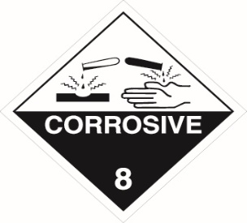
HYDROCHLORIC ACID
UN No: 1789
HAZCHEM CODE: 2R
CLASS PRIMARY: 8
SUPPLIER NAME:
SUPPLIER TEL NO:
MAXIMUM QUANTITY STORED:
This PPE MUST be worn
IN THE EVENT OF AN EMERGENCY CONTACT
NAME: NUMBER:
CARBON DIOXIDE
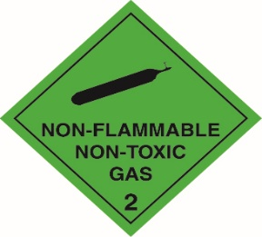
(Compressed Gas)

UN No: 1013
HAZCHEM CODE: 2T
CLASS PRIMARY: 2.2
SUPPLIER NAME:
SUPPLIER TEL NO:
MAXIMUM QUANTITY STORED:
This PPE MUST be worn
IN THE EVENT OF AN EMERGENCY CONTACT
NAME: NUMBER:
CARBON DIOXIDE
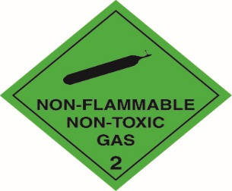
(Refrigerated Liquid)
UN No: 2187
HAZCHEM CODE: 2T
CLASS PRIMARY: 2.2
SUPPLIER NAME:
SUPPLIER TEL NO:
MAXIMUM QUANTITY STORED:
This PPE MUST be worn
IN THE EVENT OF AN EMERGENCY CONTACT
NAME: NUMBER:
CALCIUM HYPO
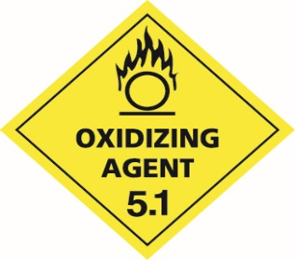
(Hydrated)
UN No: 2880
HAZCHEM CODE: 1W
CLASS PRIMARY: 5.1
SUPPLIER NAME:
SUPPLIER TEL NO:
MAXIMUM QUANTITY STORED:
This PPE MUST be worn
IN THE EVENT OF AN EMERGENCY CONTACT
NAME: NUMBER:
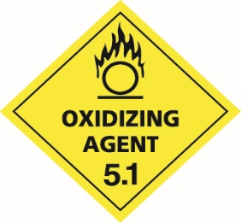
CALCIUM HYPO (Dry / Mixed)
UN No: 1748
HAZCHEM CODE: 1W
CLASS PRIMARY: 5.1
SUPPLIER NAME:
SUPPLIER TEL NO:
MAXIMUM QUANTITY STORED:
This PPE MUST be worn
IN THE EVENT OF AN EMERGENCY CONTACT
NAME: NUMBER:
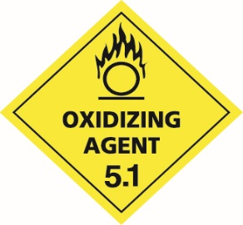
TRICHLORO-ISOCYANAURIC ACID
UN No: 2468
HAZCHEM CODE: 2WE
CLASS PRIMARY: 5.1
SUPPLIER NAME:
SUPPLIER TEL NO:
MAXIMUM QUANTITY STORED:
This PPE MUST be worn
IN THE EVENT OF AN EMERGENCY CONTACT
NAME: NUMBER:
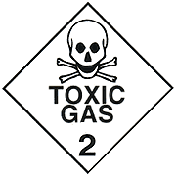
CHLORINE
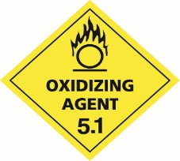
GAS
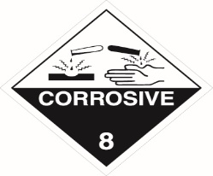
UN No: 1017
HAZCHEM CODE: 2XE
CLASS PRIMARY: 2.3
SUPPLIER NAME:
SUPPLIER TEL NO:
MAXIMUM QUANTITY STORED:
This PPE MUST be worn
IN THE EVENT OF AN EMERGENCY CONTACT
NAME: NUMBER:
SODIUM
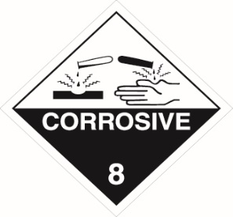
BISULPHATE
UN No: 3260
HAZCHEM CODE: 2X
CLASS PRIMARY: 8
SUPPLIER NAME:
SUPPLIER TEL NO:
MAXIMUM QUANTITY STORED:
This PPE MUST be worn
IN THE EVENT OF AN EMERGENCY CONTACT
NAME: NUMBER:
CALCIUM
CHLORIDE
UN No: NA
HAZCHEM CODE: NA
CLASS PRIMARY: NA
SUPPLIER NAME:
SUPPLIER TEL NO:
MAXIMUM QUANTITY STORED:
This PPE MUST be worn
SODIUM
IN THE EVENT OF AN EMERGENCY CONTACT
NAME: NUMBER:
BICARBONATE
UN No: NA
HAZCHEM CODE: NA
CLASS PRIMARY: NA
SUPPLIER NAME:
SUPPLIER TEL NO:
MAXIMUM QUANTITY STORED:
This PPE MUST be worn

POLYALUMINIUM
IN THE EVENT OF AN EMERGENCY CONTACT
NAME: NUMBER:
CHLORIDE
UN No: NA
HAZCHEM CODE: NA
CLASS PRIMARY: NA
SUPPLIER NAME:
SUPPLIER TEL NO:
MAXIMUM QUANTITY STORED:
This PPE MUST be worn
IN THE EVENT OF AN EMERGENCY CONTACT
NAME: NUMBER:
ISOCYANUARIC
ACID
UN No: NA
HAZCHEM CODE: NA
CLASS PRIMARY: NA
SUPPLIER NAME:
SUPPLIER TEL NO:
MAXIMUM QUANTITY STORED:
This PPE MUST be worn
IN THE EVENT OF AN EMERGENCY CONTACT
NAME: NUMBER:
DENSE
SODA ASH
UN No: NA
HAZCHEM CODE: NA
CLASS PRIMARY: NA
SUPPLIER NAME:
SUPPLIER TEL NO:
MAXIMUM QUANTITY STORED:
This PPE MUST be worn
IN THE EVENT OF AN EMERGENCY CONTACT
NAME: NUMBER:
SODIUM
THIOSULPHATE
UN No: NA
HAZCHEM CODE: NA
CLASS PRIMARY: NA
SUPPLIER NAME:
SUPPLIER TEL NO:
MAXIMUM QUANTITY STORED:
This PPE MUST be worn
IN THE EVENT OF AN EMERGENCY CONTACT
NAME: NUMBER:
ALUMINIUM
SULPHATE
UN No: NA
HAZCHEM CODE: NA
CLASS PRIMARY: NA
SUPPLIER NAME:
SUPPLIER TEL NO:
MAXIMUM QUANTITY STORED:
This PPE MUST be worn
IN THE EVENT OF AN EMERGENCY CONTACT
NAME: NUMBER:
MEDICAL OXYGEN
(Compressed)

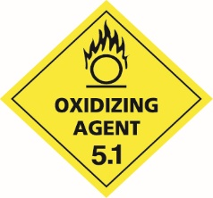
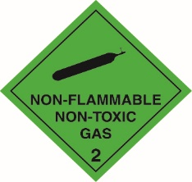
UN No: 1072
HAZCHEM CODE: NA
CLASS PRIMARY: 2.2
SUPPLIER NAME:
SUPPLIER TEL NO:
MAXIMUM QUANTITY STORED:
This PPE MUST be worn
IN THE EVENT OF AN EMERGENCY CONTACT
NAME: NUMBER:

